**SQL-Leet Code-Challenge**

**Q1). Finding the Duplicate records in the table?**

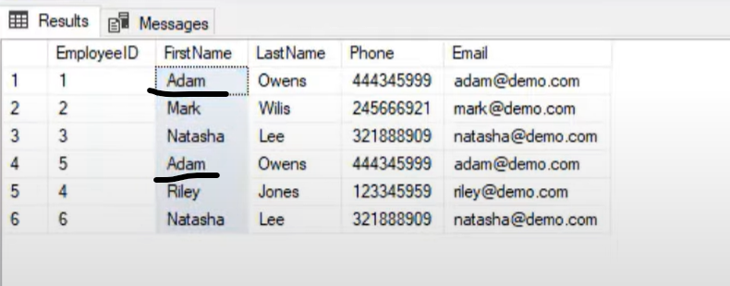

SOLUTION:-

SELECT FIRSTNAME, LASTNAME, COUNT(*) total count FROM Employess

GROUP BY FIRSTNAME, LASTNAME'

HAVING COUNT(*)>1

***************Using the Rank Function*******************

With Employee_duplicates as

(SELECT Employee_ID, FIRSTNAME, LASTNAME,

RANK() OVER(Partition by  FIRSTNAME, LASTNAME order by Employee_ID) as RANK_NUMB

FROM Employee)

DELETE FROm Employee_duplicates where RANK_NUMB>1

**Q2). Finding Nth highest salary of the employee from the table?**

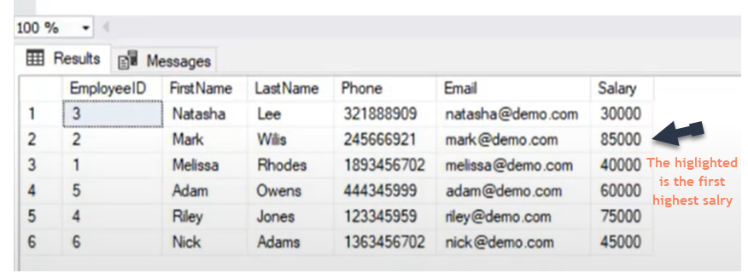

SELECT Firstname, lastname,Department, SALARY from EMPLOYEE

WHERE SALARY = (SELECT max(SALARY) FROM EMPLOYEE)

**Getting the highest salary by using the desc order salary**

select top 1 * from EMPLOYEE -----Top Two highest salaries

order by SALARY desc

select top 2 * from EMPLOYEE

order by SALARY desc

**Getting the any highest salary from the result set i.e getting the 15th highest salary**

select top 1 * FROM

(select top 15 * from EMPLOYEE

order by SALARY desc

)

order by SALARY ASC---->getting the 15th Hishest salary as it's the lowest salary out of the 15 records dynamically…

We can apply same logic for any records

SELECT * FROM EMPLOYESS

ORDER BY SALARY DESC

limit 1 offset 14 ------This will result the 15th  highest salary

**Getting the higest salaries based upon the Dense_Rank function**

with Employee_salary as (

SELECT *, DENSE_RANK() OVER(PARTITION BY DEPARMENT ORDER BY SALARY DESC) AS rank FROM EMPLOYESS

)

select * from Employee_salary where rank =2 -----will give the second higest salary

**Q3). Finding the Employees corresponding Managers details from the table ?**

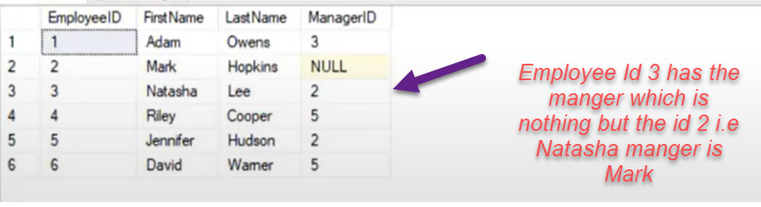

SOLUTION:-

Select emp.Fistname + '' + emp.Fistname as EmployeeName

mngr.Fistname + '' + mngr.Fistname as MangerName

from EMPLOYEE emp INNER JOIN EMPLOYEE mngr

ON emp.Employee_id = mngr.Manger_id

**Q3). Finding the employees who’s salary is greater than their managers salary?**

SELECT FirstName,LastName,Employee_Id,Manager_Idsalary from Employee emp

where salary>= (select salary from Employee mng where emp.Employee_Id = mng.Manager_Id)

SELECT FirstName,LastName,Employee_Id,Manager_Idsalary from Employee emp inner join  Employee mng

ON emp.Employee_Id = mng.Manager_Id

AND emp.salary>mng.salary

**Q3). Find the Employee salary who’s having less than average salary of the department but greater than the average salary of any other departments?**

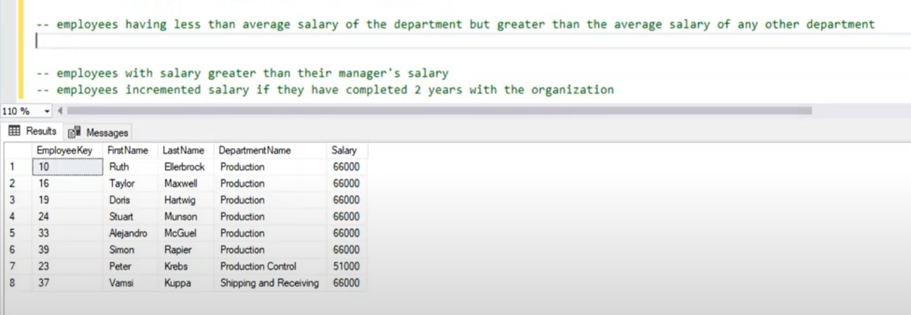

SELECT EmployeeKey,Firstname,LastName,Emp.DepartmentName,salary from EMPLOYEES Emp

INNER JOIN

(

SELECT DepartmentName,avg(salary) as Avgsale from EMPLOYEES

GROUP BY

DepartmentName) as DeptAvg

ON Emp.DepartmentName = DeptAvg.DepartmentName

AND Emp.salary<= DeptAvg.Avgsale

where Emp.salary> ANY(select avg(salary) from EMPLOYEE GROUP BY DepartmentName)

**Q3). Find The Employees with highest salary in the department wise**

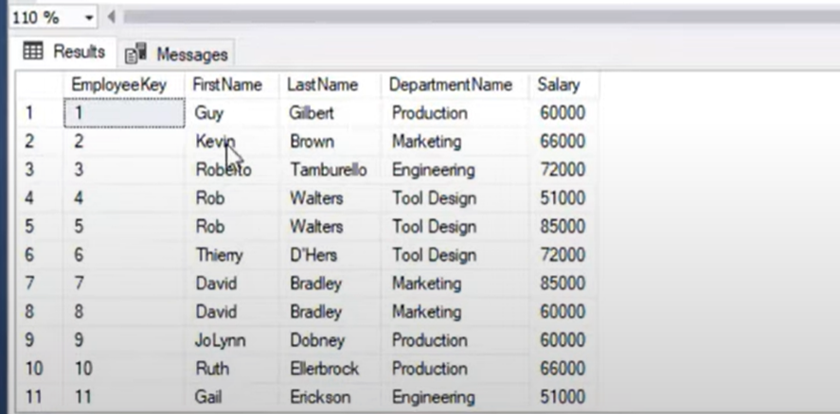

SOLUTION:-

SELECT EmployeeKey,Firstname,LastName,Emp.DepartmentName,salary from EMPLOYEES Emp

INNER JOIN

(

SELECT DepartmentName,MAX(salary) as maxsala from EMPLOYEES

GROUP BY

DepartmentName) as MaxSalesEmp

ON Emp.DepartmentName = DeptAvg.DepartmentName

AND Emp.salary =  MaxSalesEmp.maxsala

Alternate Query with the Rank

SELECT EmployeeKey,Firstname,LastName,DepartmentName,salary

RANK() OVER(partition by DepartmentName order by salary desc) as Rank_sale

from EMPLOYEES

**Q3). Find employees salary who is having greater than average salary of the department?**

SELECT EmployeeKey,Firstname,LastName,Emp.DepartmentName,salary from EMPLOYEES Emp

INNER JOIN

(

SELECT DepartmentName,Avg(salary) as Avgsal from EMPLOYEES

GROUP BY

DepartmentName) as AvgEmpsale

ON Emp.DepartmentName = DeptAvg.DepartmentName

AND Emp.salary >  AvgEmpsale.Avgsal

Other Solution

SELECT E1.EMPNAME,E1.DeptId, E1.SALARY

FROM EMPLOYEE E1 WHERE SALARRY >

(

    SELECT Avg(SALARRY) FROM EMPLOYEE E2

    ON E1.DeptId = E2.DeptId

)

**Q3). Capitalization of the first letter of the string ?**

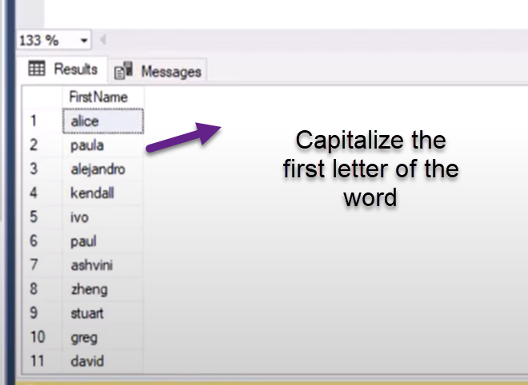

SELECT UPPERCASE(Left(NAME,1)) + Substr(NAME,2,length(Name)) FROM EMPLOYEE

**Q3). Find the retainment age for the date birth to employee?**

SELECT firstname,lastname, Add_YEARS("Birthday",60) as Retairment_age from Employee

**Q3). Counting the number of occurrences of a character in the String?.**

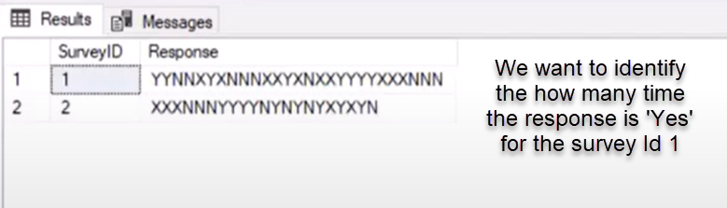

Select SurveyId, Response,Totallength-required_length as occurence of Y

FROM

(SELECT SurveyId, Response, length(Response) as Totallength, Replace(Response,'Y',''),length(Replace(Response,'Y','')) as required_length

from Employee)

**Q3). Find the names that starts and ends with the character ‘a’?**

SELECT Firstname from Employee

where  Firstname like '%a' AND Firstname like 'a%'

SELECT Firstname from Employee

where  Firstname like '%a'

AND Firstname like_regexpr '[A-Z]'

**Q3). Find the lower case values from the string column values?**

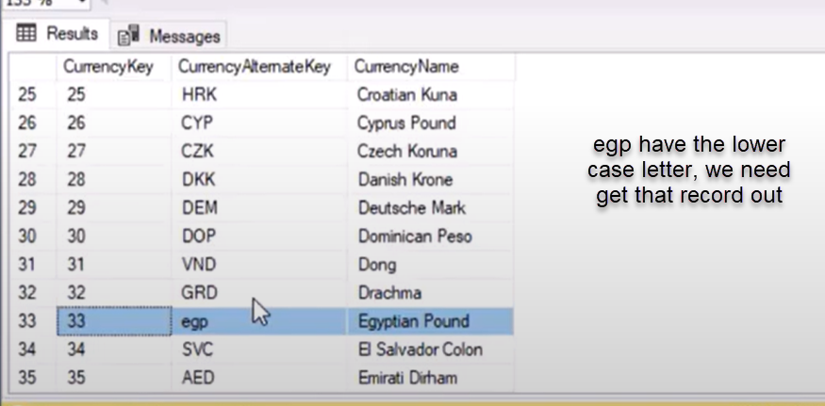

SELECT CurrencyAlternateKey, uppercase(CurrencyAlternateKey) From CurrencyTable

WHERE upper(CurrencyAlternateKey)!= CurrencyAlternateKey

**Q3). Difference between the Count(*),Count(1) and Count(column)**

**The Count (*) will include the null values as the count value in the result set**

**The Count(column) will not include the counting the null values in the result set meaning it will include only the not null values in the result**

**Q3). Find the No sales for consecutive days and identify the gaps in days**

SELECT EmployeeId, Firstname,lastname, order_date,lead_date

DAYS_BETWEEN(order_date,lead_date) as gap

(

SELECT EmployeeId, Firstname,lastname, order_date,

lead(order_date) Over(order by order_date) as lead_date

FROM Employees

order by order_date

)

WHERE DAYS_BETWEEN(order_date,lead_date) >1

**Alternate solution**

SELECT EmployeeId, Firstname,lastname, order_date,

Days_Between(Order_Date,(lead(order_date) Over(order by order_date))) as gap

FROM Employees

order by order_date

**Where** Days_Between(Order_Date,(lead(order_date) Over(order by order_date)))>1

**Q3). Comparing the current sales amount with the Previous sales amount for the year and month level ?.**

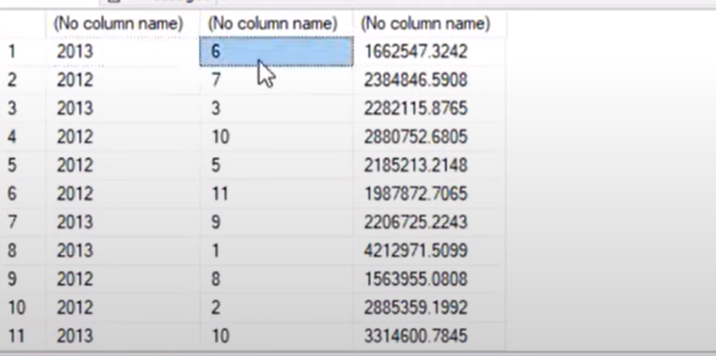

SELECT Employee, year, month, SalesAmount-previoussales

FROM

(Select Employee, year(Orderdate) as Year, month(orderdate) as month, sum(SalesAmount) as SalesAmount,

Lag(sum(SalesAmount)) OVER(order by  year(Orderdate), month(orderdate)) as previoussales

From Sales_Info

Group by Employee, year(Orderdate), month(orderdate)

)

**Q3). Comparing the current month of current year sales amount with the previous year of the same month sales amount?**

Select Employee, year(Orderdate) as Year, month(orderdate) as month, sum(SalesAmount) as SalesAmount,

Lag(sum(SalesAmount),12) OVER(order by  year(Orderdate), month(orderdate)) as previoussales

From Sales_Info

Group by Employee, year(Orderdate), month(orderdate)

**Lag(sum(SalesAmount),12)---> essentialy this will populate the null value for the previoussales column values and populate**

**previoussales value for the previous first month side**

**Q3). Comparing the current month of current year sales amount with all the remaining months ?**

Select Employee, year(Orderdate) as Year, month(orderdate) as month, sum(SalesAmount) as SalesAmount,

Lag(sum(SalesAmount), month(orderdate)-1) OVER(order by  year(Orderdate), month(orderdate)) as previoussales

From Sales_Info

Group by Employee, year(Orderdate), month(orderdate)

**Q3). Extracting the domain name from the given email id?**

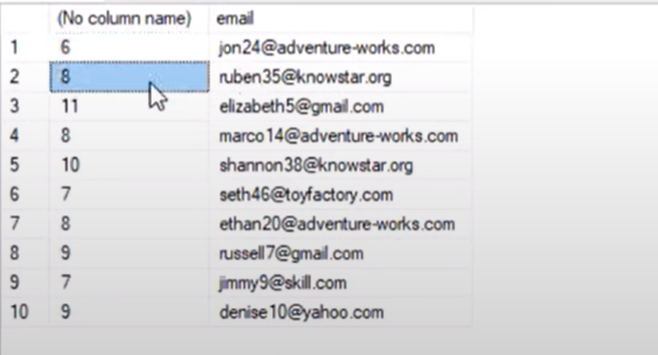

SELECT CharIndex('@',email) from Employee

SELECT count(*), Rightstr(email,lenghth(email)-CharIndex('@',email)) from Employee

Group by

Rightstr(email,lenghth(email)-CharIndex('@',email))

**Q3). How Find all levels of employee manager hierarchy Recursion ?**

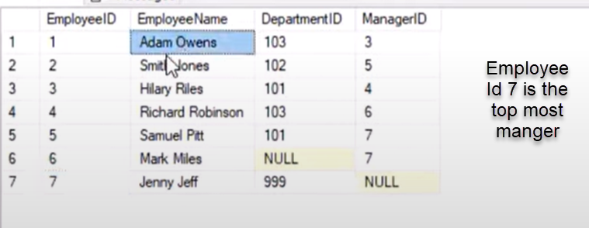 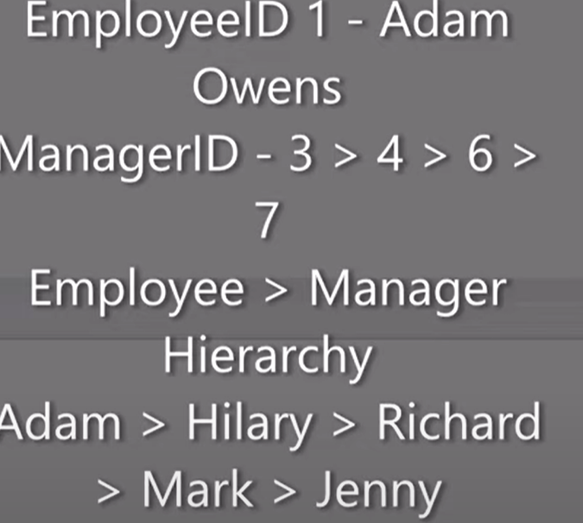

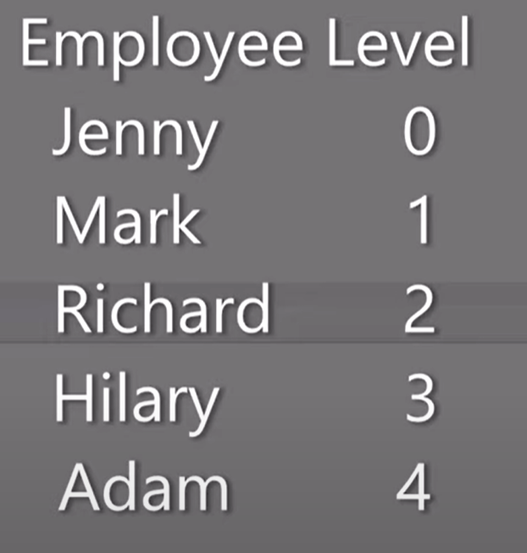

With MangHier as

( SELECT EmployeeId, EmployeeName, ManagerId, 0 as EmployeeLevel

From Employee

WHERE

ManagerId is null

UNION ALL

SELECT emp.EmployeeId, emp.EmployeeName, emp.ManagerId, EmployeeLevel+1 as EmployeeLevel

From Employee emp

INNER JOIN MangHier as mgr

ON emp.ManagerId = mgr.EmployeeId

)

SELECT * FROM MangHier;

**Q3). Finding the Rank,Row_Number and dense Rank?**

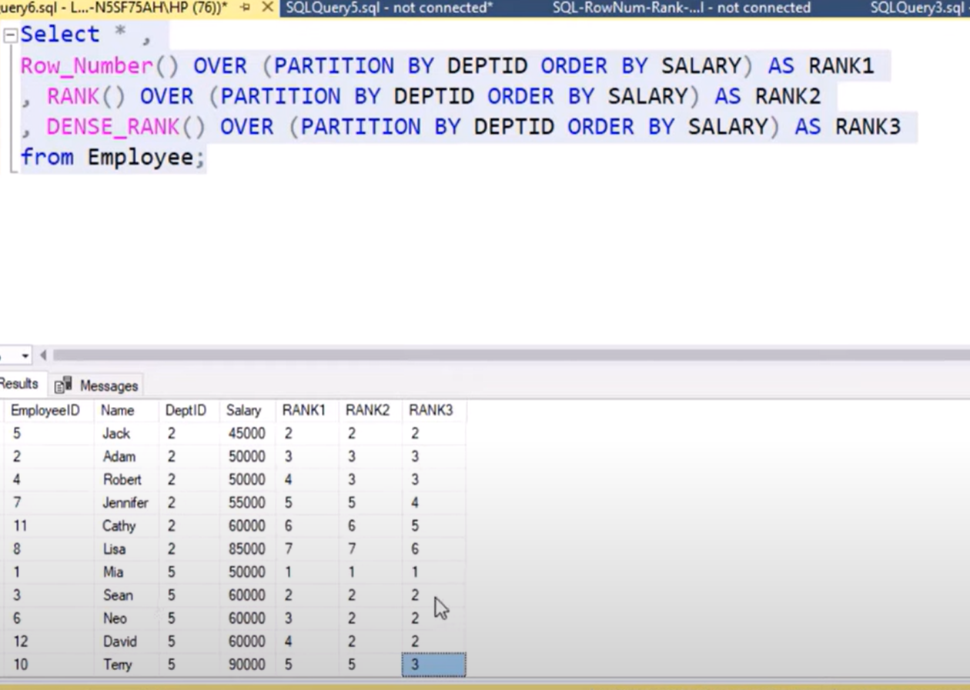

**Q3). How many times the String ‘Yes’ is repeated?**

SELECT StringVal, (strlengt-yeslength)/length('yes') as find

FROM

(

SELECT StringVal,length(replace(StringVale,'yes','')) as yeslength, length(StringVale) as strlengt)

**Q3). Display the minimum and Max sequence?.**

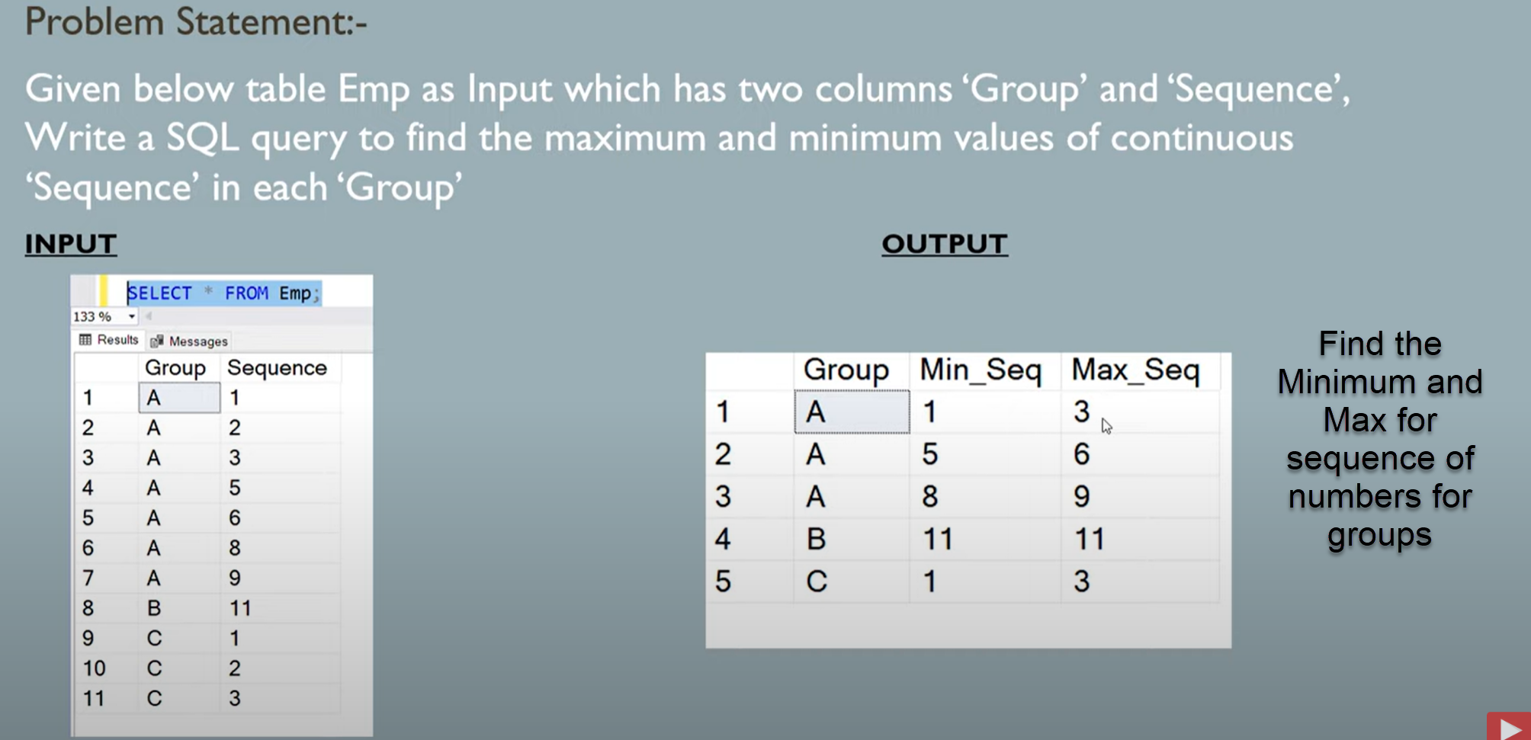

SELECT Group,

Max(Sequence),

Min(Sequence)

FROM

(SELECT Group, Sequence, ROW_NUMBER() OVER(Partition by Group order by Sequence) as Rank,

Sequence- ROW_NUMBER() OVER(Partition by Group order by Sequence) GroupRank

FROM EMPLOYEE_TABLE

)

GROUP BY

Group,

GroupRank

order by GroupRank

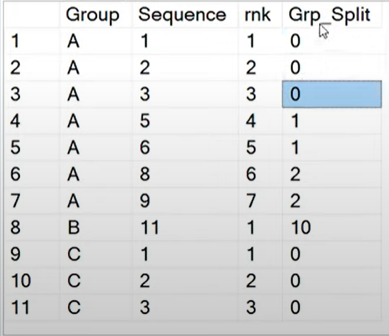

**Q3). Display Previous years marks whose Total marks are greater than or equal to previous year ?.**

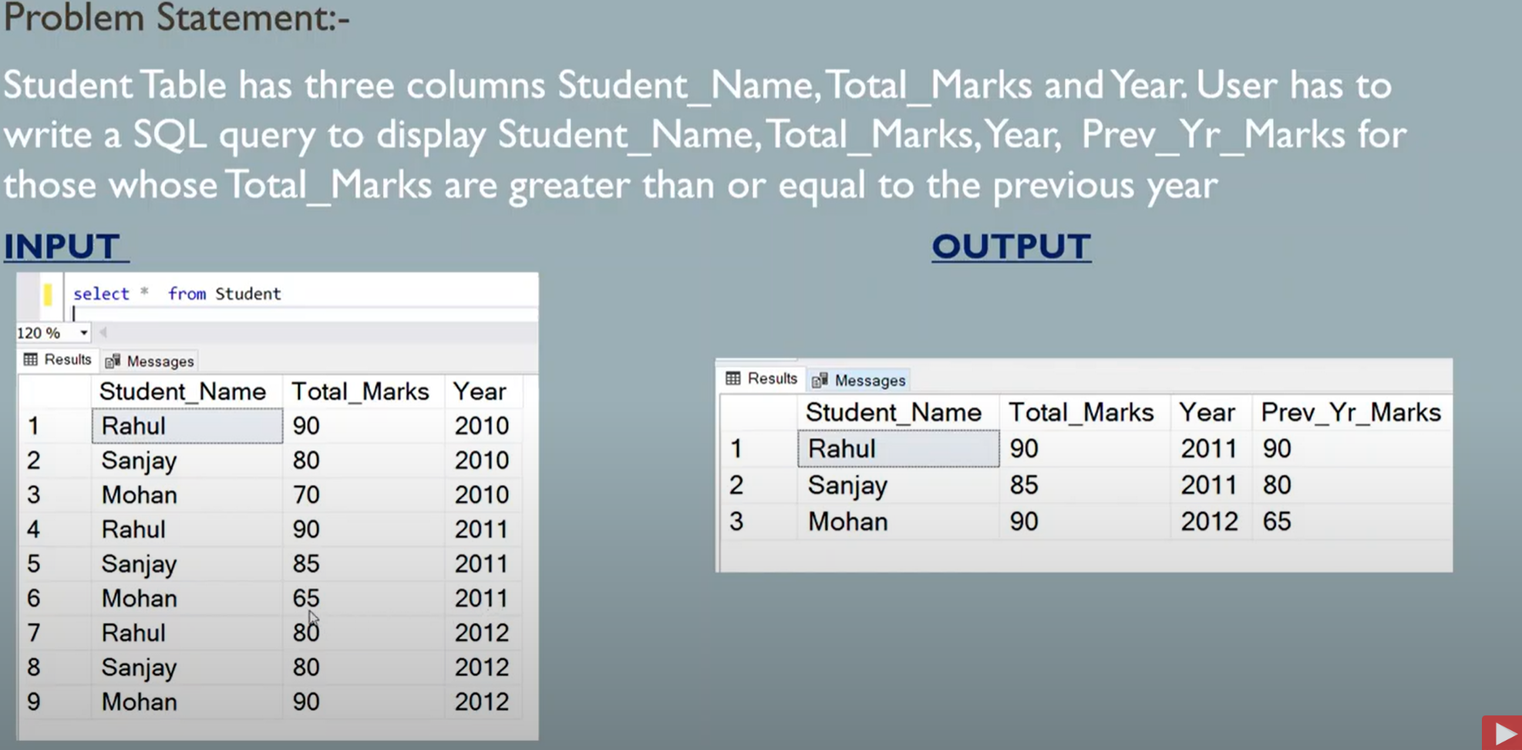

SELECT StudentName,year,Total_Marks

FROM

(SELECT StudentName,year,Total_Marks,

LAG(Total_Marks) over(partition StudentName order by year desc) as Previouse_Marks,

CASE WHEN Total_Marks>= (LAG(Total_Marks) over(partition StudentName order by year desc)) Then 1 else 0 end as Flag

FROM STUDENTS

)

WHERE Flag=1;

**Q3).Finding the product how many times order ?.**

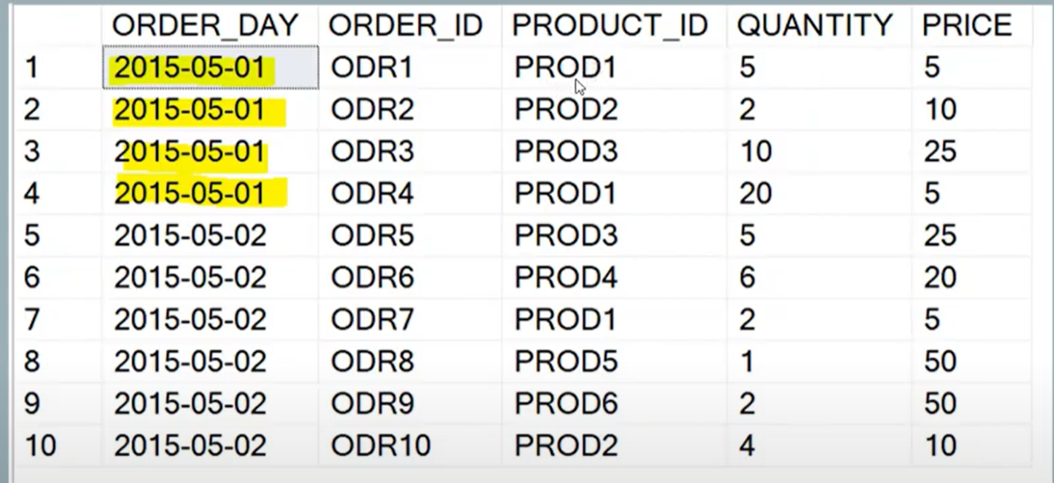

SELECT Product_id, count(Product_id) as count , count(distinct order_day)

from

GROUP BY Product_id

HAVING count(distinct order_day)>1

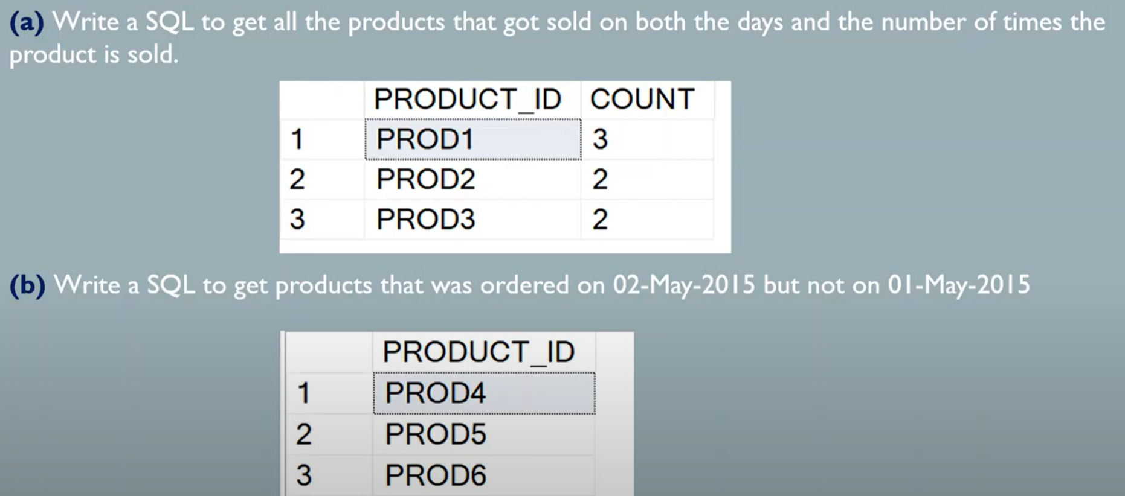

**Q3). Find the Products that was sold on the 2nd May but on the 1st May.**

SELECT DISTINCT(PRODUCT_ID) FROM ORDER_TABLE

WHERE ORDER_DAY = '2015-05-02'

AND PRODUCT_ID NOT IN(SELECT PRODUCT_ID FROM ORDER_TABLE WHERE ORDER_DAY = '2015-05-01')

**------------------------------------------**

SELECT A.PRODUCT_ID,B.PRODUCT_ID

FROM

(

(SELECT PRODUCT_ID FROM ORDER_TABLE WHERE ORDER_DAY = '2015-05-01')

as a LEFT OUTER JOIN

(

SELECT PRODUCT_ID FROM ORDER_TABLE WHERE ORDER_DAY = '2015-05-01'

) as b

on a.PRODUCT_ID = b.PRODUCT_ID

)

WHERE b.PRODUCT_ID is null

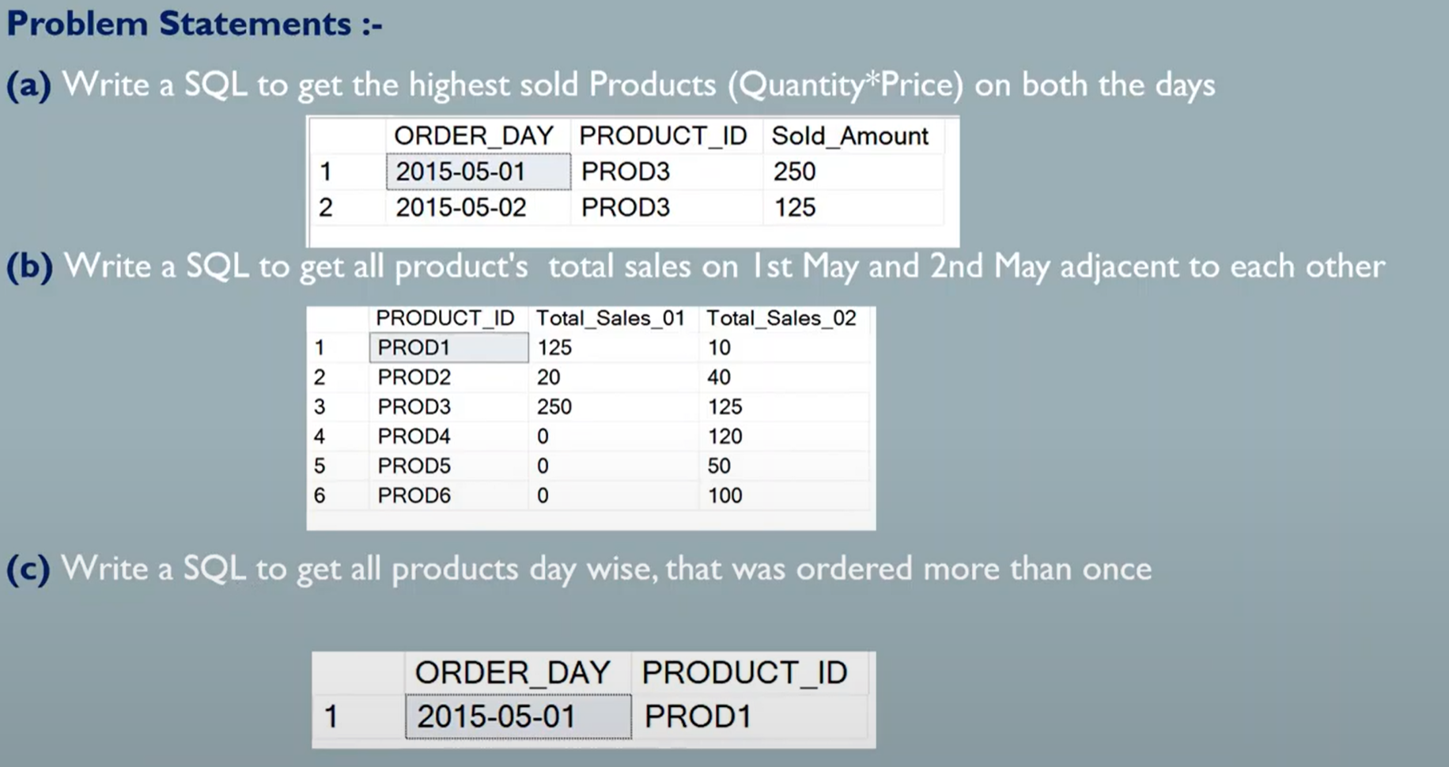

**Q3). Write the SQL to get highest sold products (Quantity*Price) on both days?**

SELECT ORDER_DAY, PRODUCT_ID,TOTAL FROM

(

(SELECT ORDER_DAY, PRODUCT_ID, MAX(QUANTITY*PRICE) AS TOTAL FROM ORDER_TABLE

WHERE ORDER_DAY='2015-05-01'

GROUP BY

ORDER_DAY, PRODUCT_ID

)

UNION ALL

(SELECT ORDER_DAY, PRODUCT_ID, MAX(QUANTITY*PRICE) AS TOTAL FROM ORDER_TABLE

WHERE ORDER_DAY='2015-05-01'

GROUP BY

ORDER_DAY, PRODUCT_ID

)

)

**Q3). Write the SQL to get 2015-05-01 and 2015-05-02 product total sales in separate columns in the output?**

SELECT  PRODUCT_ID, SUM(TOTAL_SALE_1) AS TOTAL_SALE_1, SUM(TOTAL_SALE_2) ASS TOTAL_SALE_2

FROM

(

SELECT ORDER_DAY, PRODUCT_ID,  SUM(QUANTITY*PRICE) AS TOTAL_SALE_1  FROM ORDER_TABLE

WHERE ORDER_DAY='2015-05-01'

GROUP BY

ORDER_DAY,

PRODUCT_ID

UNION ALL

SELECT ORDER_DAY, PRODUCT_ID,  0 TOTAL_SALE_1, SUM(QUANTITY*PRICE) AS TOTAL_SALE_2  FROM ORDER_TABLE

WHERE ORDER_DAY='2015-05-02'

GROUP BY

ORDER_DAY,

PRODUCT_ID

)

GROUP BY

PRODUCT_ID

**Q3). Write the SQL to Products that was ordered twise as day.**

SELECT ORDER_DAY PRODUCT_ID,count(*)

from

GROUP BY ORDER_TABLE

HAVING count(*)>1

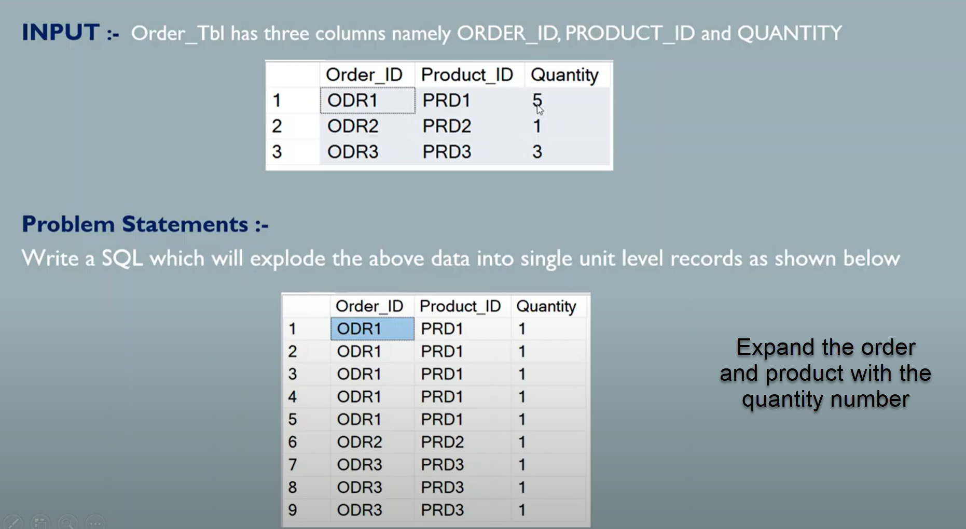

**Q3). Expand the Order_id and Product_id records to multiple records as per the Quantity number**

With CTE as

(----Anchor Query

SELECT ORDER_ID, PRODUCT_ID, 1 AS QUANTITY, 1 AS CNT

FROM ORDER_TABLE

UNION ALL

SELECT A.ORDER_ID, A.PRODUCT_ID,B.QUANTITY,CNT+1

FROM ORDER_TABLE AS A INNER JOIN CTE AS B

ON A.PRODUCT_ID = B.PRODUCT_ID

WHERE B.CNT+1 <= A.QUANTITY

)

SELECT ORDER_ID, PRODUCT_ID, QUANTITY FROM CTE;

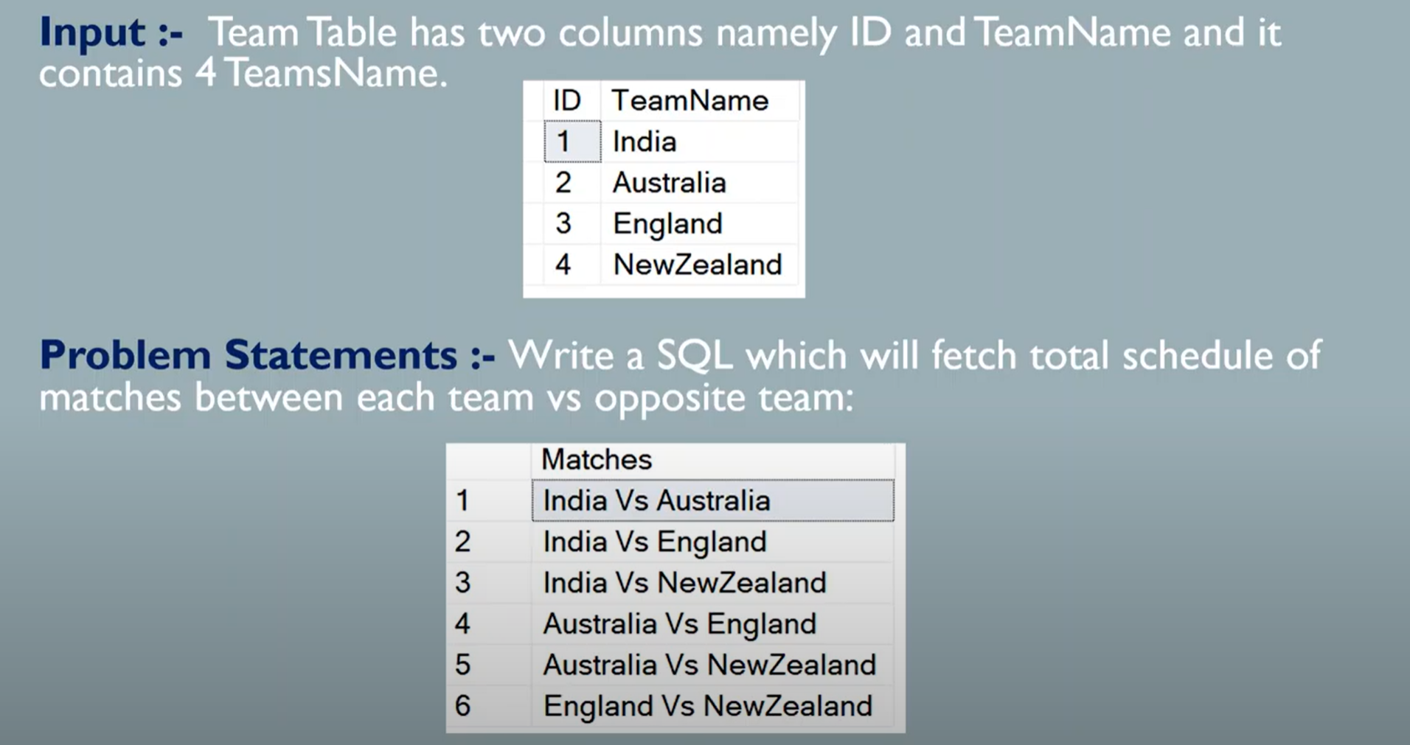

**Q3). Find the possible matches between the Teams**

SELECT T1.ID, concat(concat(T1.TEAM,' vs '),T2.TEAM)

FROM TEAM AS T1

INNER JOIN

(SELECT ID, TEAM FROM TEAM )AS T1

ON T1.ID < T2.ID

**Q3). Playing the Matches within the team itself?**

SELECT T1.ID, concat(concat(T1.TEAM,' vs '),T2.TEAM)

FROM TEAM AS T1

INNER JOIN

(SELECT ID, TEAM FROM TEAM )AS T1

ON T1.ID = T2.ID

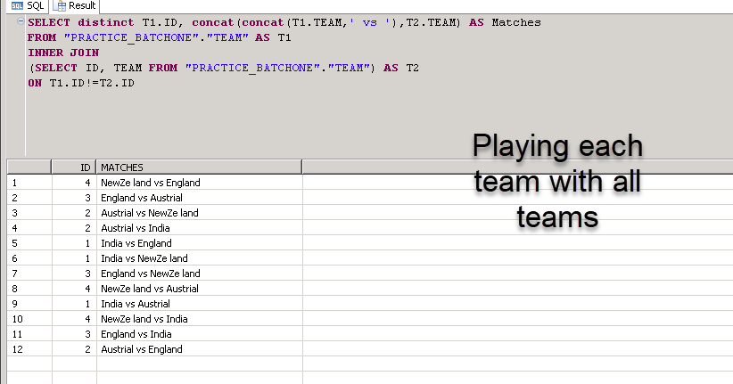

**Q3). Find the output for the below joining conditions**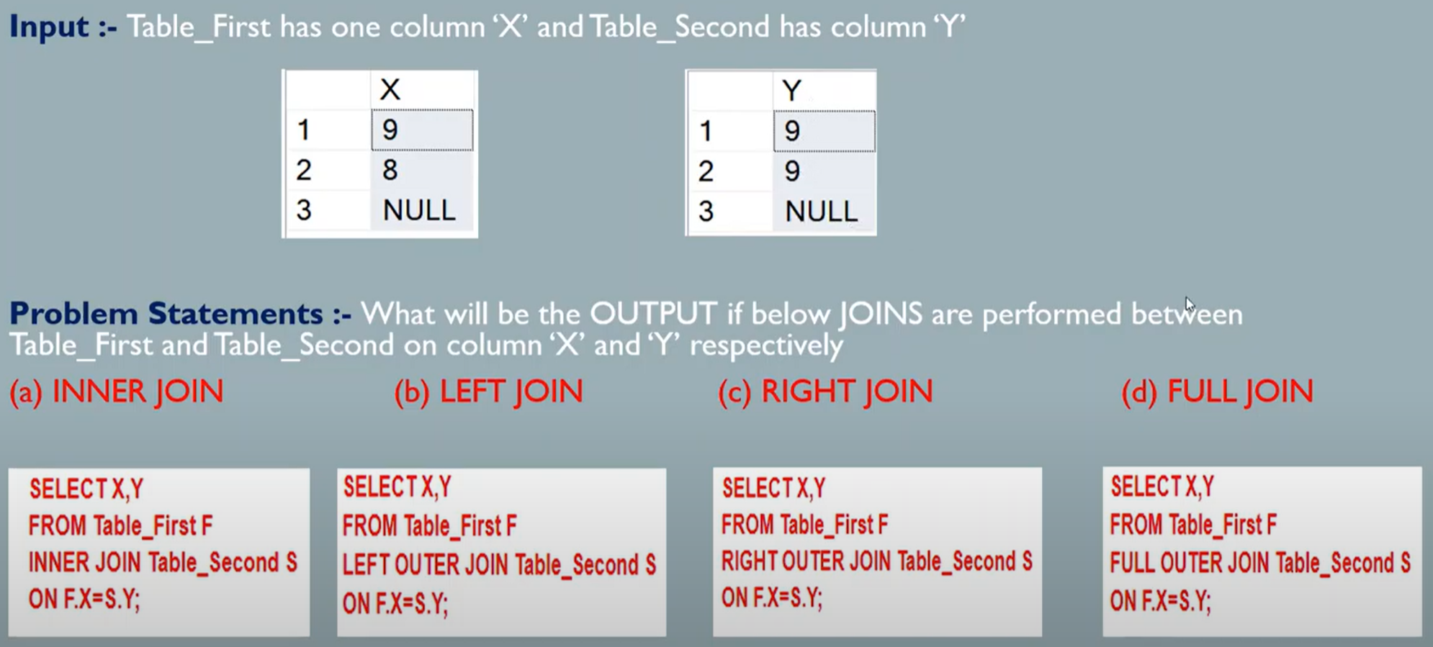

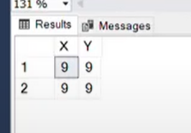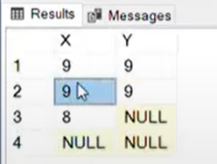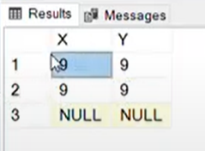

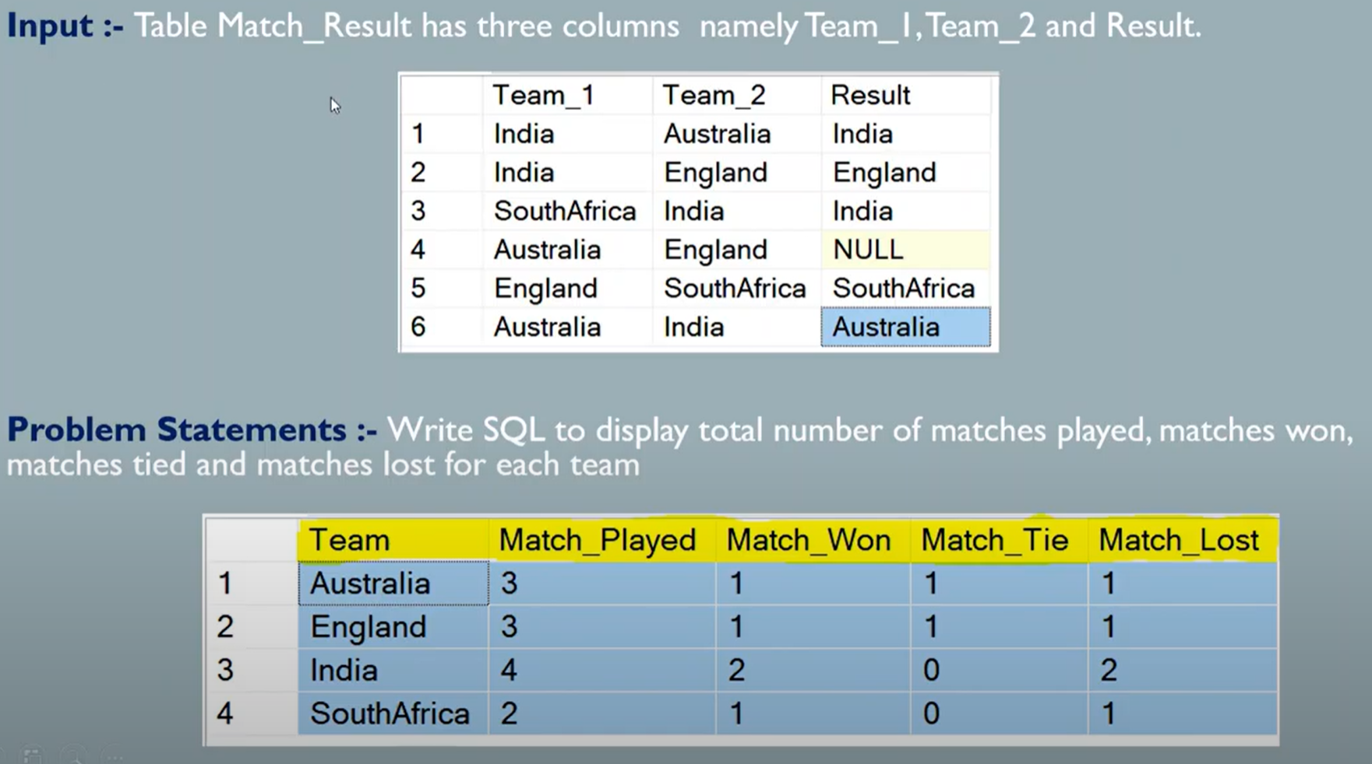

**Q3). Find the number of matched played, Match Won, Match lost and Match Tie?.**

**Copy the Code from the ThinSolution**

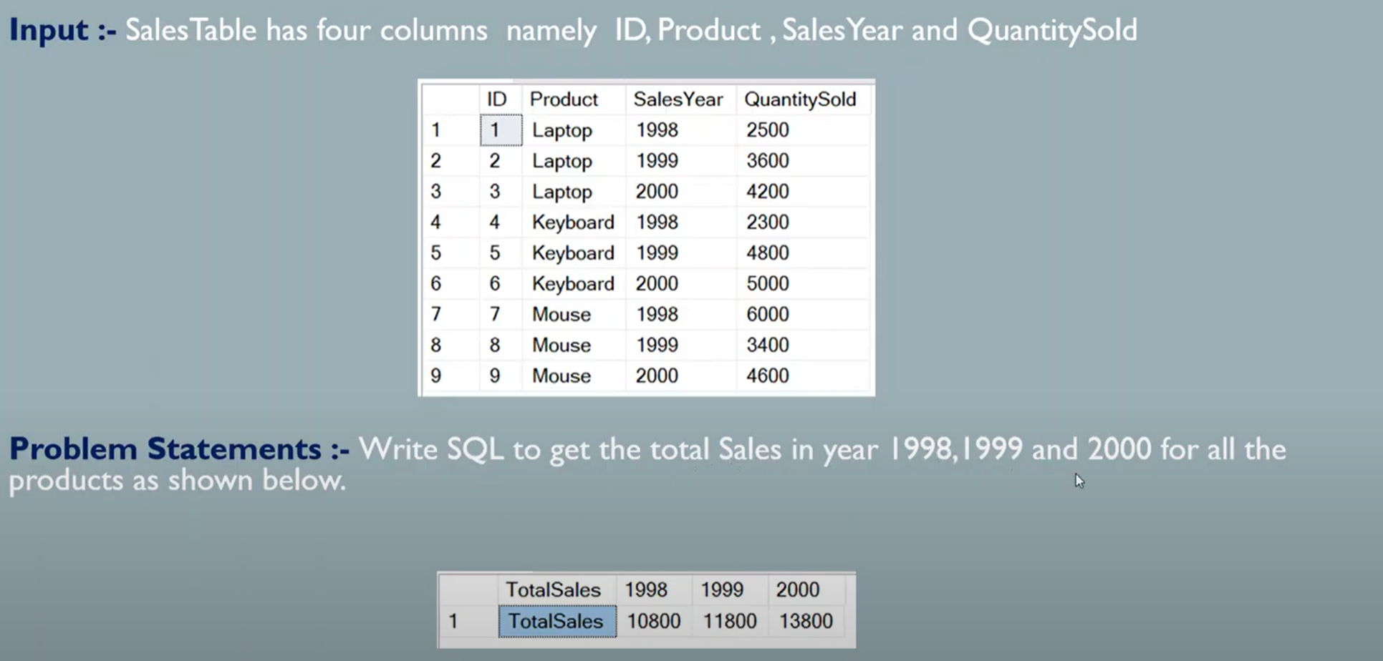

**Q3). Find the Total sales for the year for 1998,1999,2000**

SELECT 'Total_Sales' sa Total_Sales, SUM(1998) AS '1998', SUM(1999) AS '1998', SUM(2000) AS '2000'

(CASE WHEN SALES_YEAR = 1998 Then SUM(QuantitySold) End '1998',

CASE WHEN SALES_YEAR = 1999 Then SUM(QuantitySold) End '1999',

CASE WHEN SALES_YEAR = 2000 Then SUM(QuantitySold) End '2000',

FROM SALES

GROUP SALES_YEAR

)

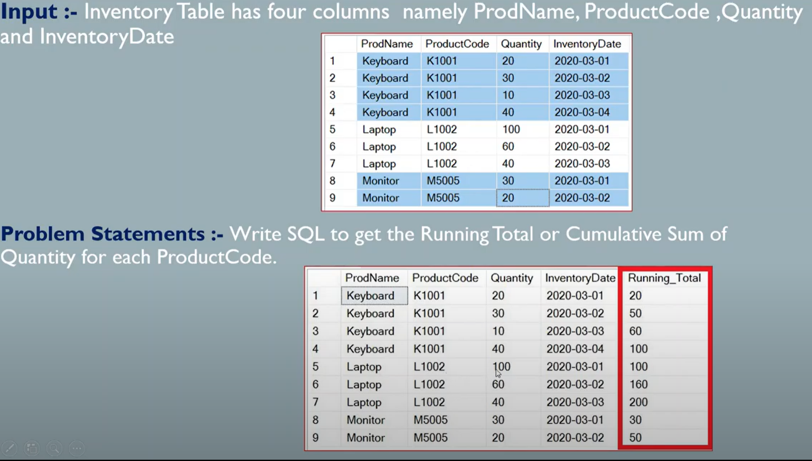

**Q3). Find the Cumulative Sum base on the Product Code?**

SELECT PRODUCTNAME, PRODUCTCODE,QUANTITY,INVENTORYDATE

SUM(QUANTITY) OVER(PARTITION BY PRODUCTCODE ORDER BY INVENTORYDATE )

FROM PRODUCT_ORDER

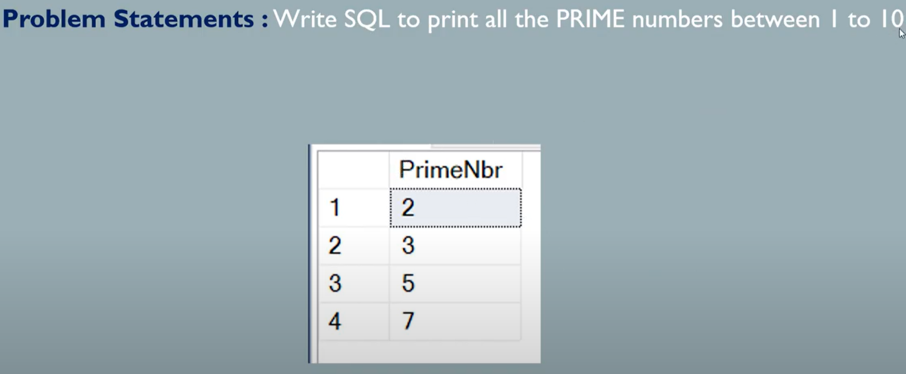

**Q3). Find the Prime numbers from 1 to 10 ?.**

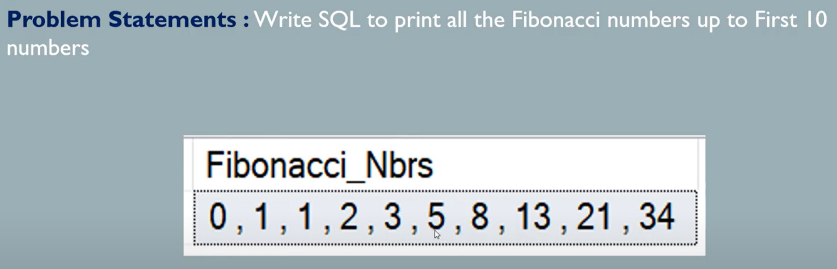

**Q3). Find the Fibonacci Series Numers ?.**

With FIBONACCI as (

SELECT 0 as FIRST, 1 AS SECOND , 1 AS STEP FROM DUMMY

UNION ALL

SELECT SECOND, SECOND+FIRST, STEP+1

FROM FIBONACCI

WHERE STEP<10

)

SELECT STRING_ARRG(FIRST,',') AS Fibonaci_series from FIBONACCI

GROUP BY

FIRST

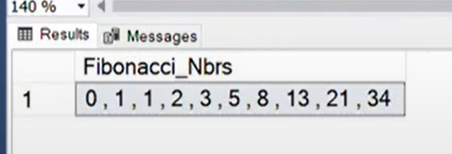

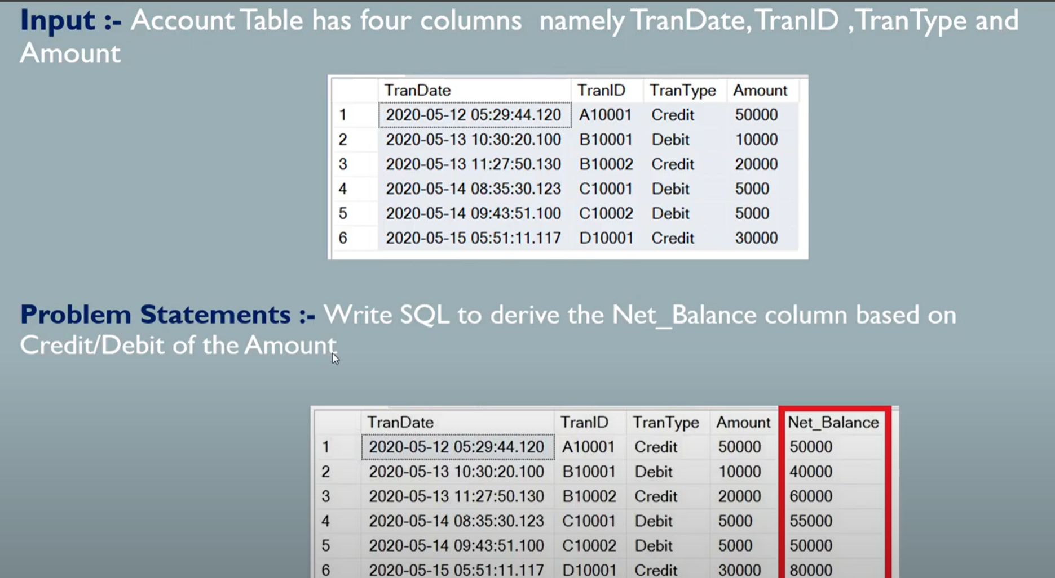

**Q3). Find the Net_Balance Amount based on the Credit and Debit ?.**

SELECT TRANS_DATE, TRANS_ID, TRANS_TYPE,AMOUNT, SUM(TEMP_AMOUNT) OVER(ORDER BY TRANS_DATE) AS NET_BALANCE

FROM

(SELECT TRANS_DATE, TRANS_ID, TRANS_TYPE,AMOUNT,

CASE WHEN TRANS_TYPE ='Credit' THEN AMOUNT

     WHEN TRANS_TYPE ='Debit' THEN AMOUNT*-1 THEN TEMP_AMOUNT

)

************************With the CTE********************

WITH CTE AS

(SELECT TRANS_DATE, TRANS_ID, TRANS_TYPE,AMOUNT,

CASE WHEN TRANS_TYPE ='Credit' THEN AMOUNT

     WHEN TRANS_TYPE ='Debit' THEN AMOUNT*-1 THEN TEMP_AMOUNT

)

SELECT TRANS_DATE, TRANS_ID, TRANS_TYPE,AMOUNT, SUM(TEMP_AMOUNT) OVER(ORDER BY TRANS_DATE) AS NET_BALANCE

FROM CTE

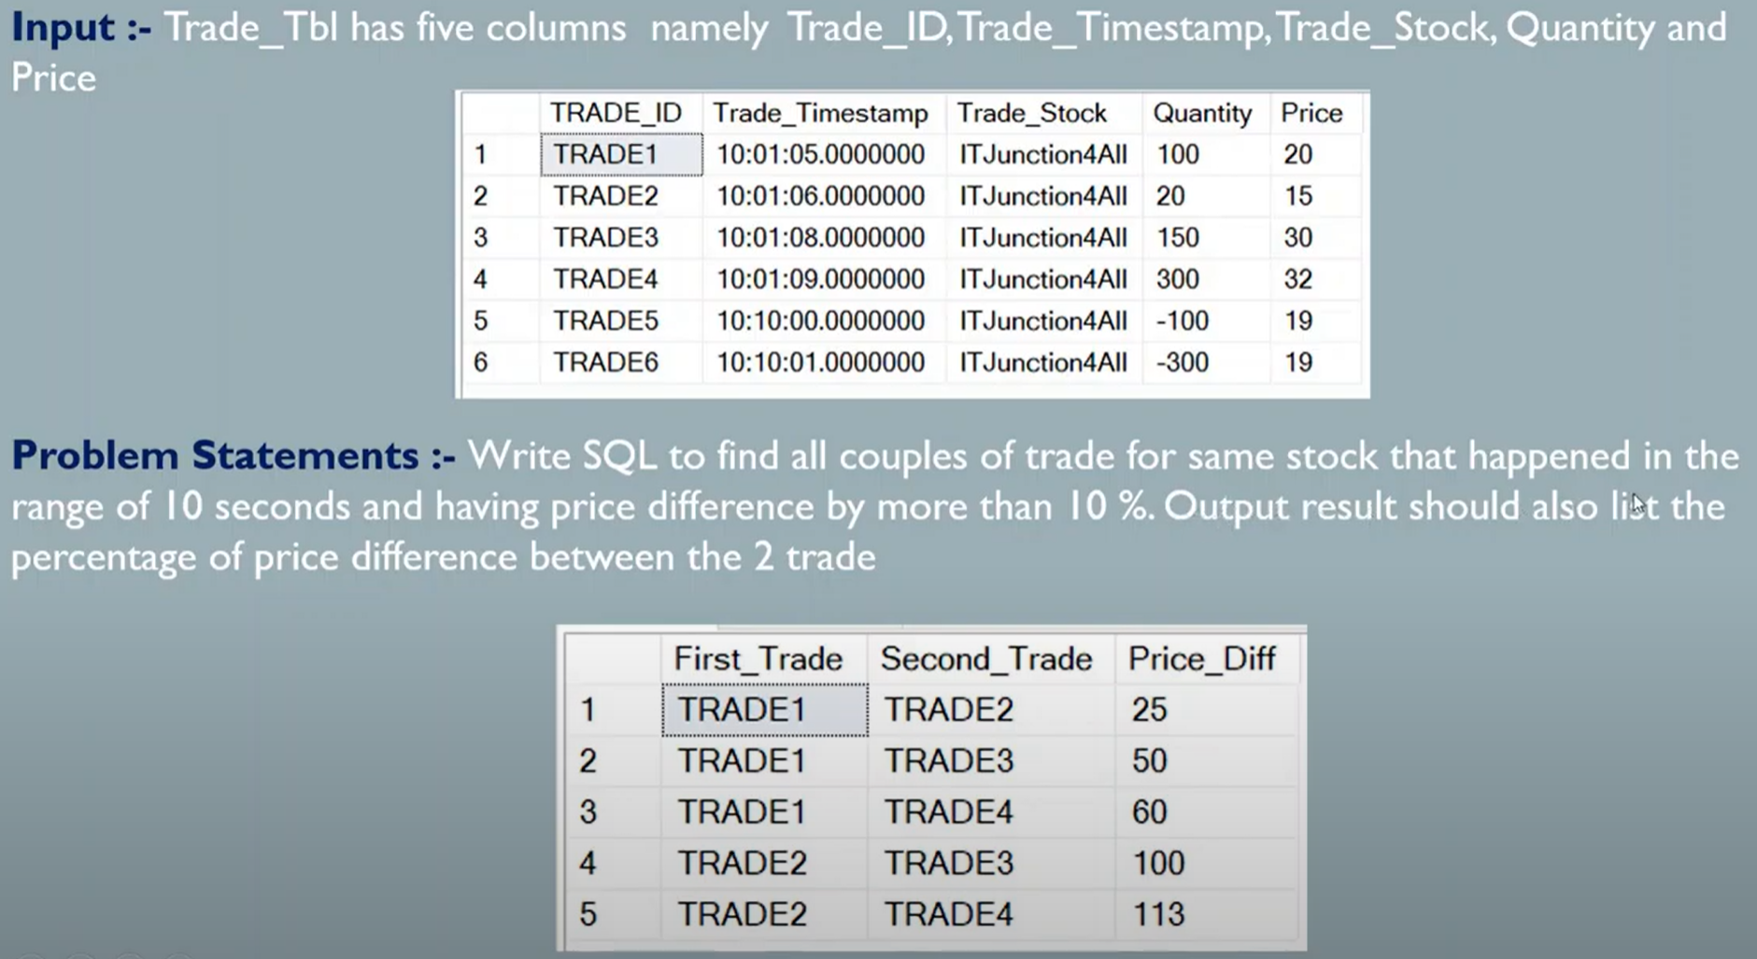

**Q3). Find the Traders for same stock?.**

With TRADE_CTE as (

    SELECT TRADE_ID, TRADE_TIMESTAMP,PRICE FROM TRADE_TABLE           ----ABS(-25)-->25

)

    SELECT A.TRADE_ID First_Trade,B.TRADE_ID Second_Trade,             ----FLOOR(100.24)-->100

    FLOOR(ABS(((B.PRICE-A.PRICE)/A.PRICE)*100)) as Price_Diff

FROM TRADE_CTE AS A

INNER JOIN  TRADE_CTE AS B

ON A.TRADE_ID<B.TRADE_ID

WHERE SECONDS_BETWEEN(A.TRADE_TIMESTAMP, B.TRADE_TIMESTAMP)<=10

AND  FLOOR(ABS(((B.PRICE-A.PRICE)/A.PRICE)*100))>=10

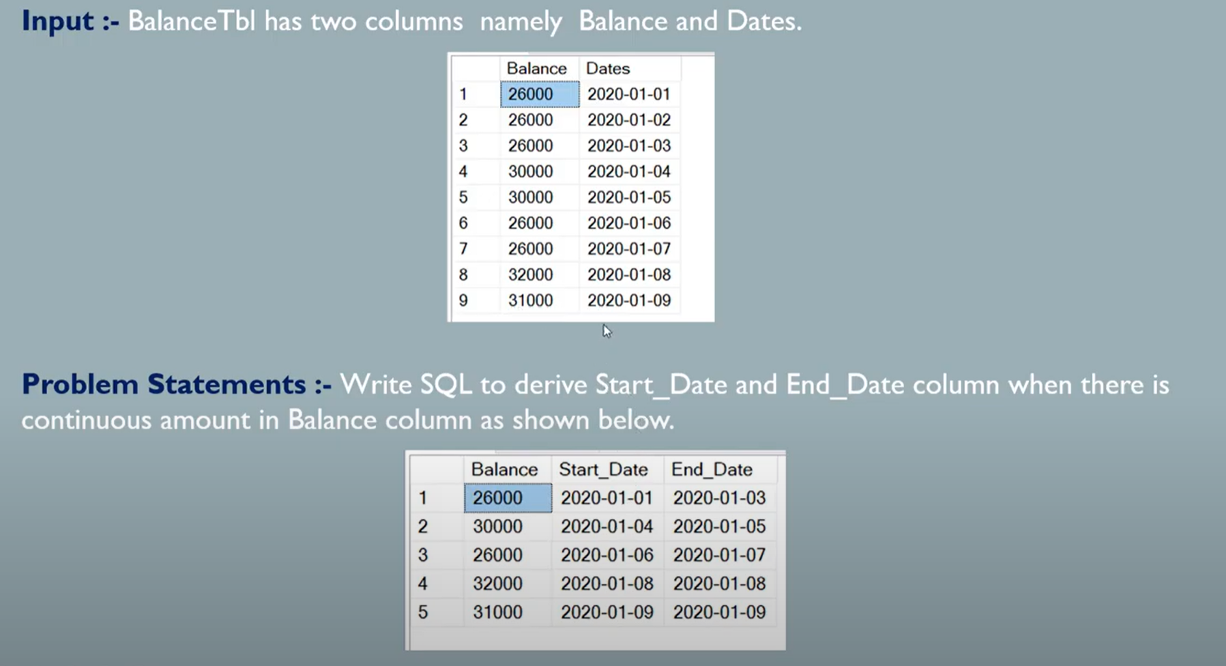

WITH Balance_CTE as

(

SELECT Balance, Dates, LAG(Balance) OVER(order by Dates) as lag_Balance,

CASE WHEN LAG(Balance) OVER(order by Dates) =  Balance THEN 0 ELSE 1 END as TempSeq

FROM BALANCE_TABLE

),

Sequence_CTE as

(

  SELECT Balance, Dates, SUM(TempSeq) OVER(ORDER BY DATES) AS SEQ

  FROM Balance_CTE

)

SELECT Balance,

Min(Dates) as Start_Date,

Max(Dates) as End_Date,

FROM Sequence_CTE

GROUP BY SEQ, Balance

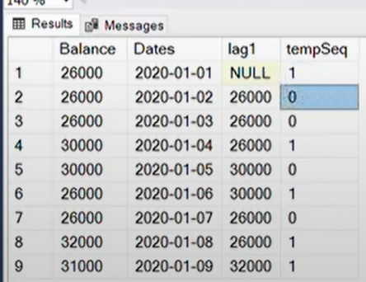

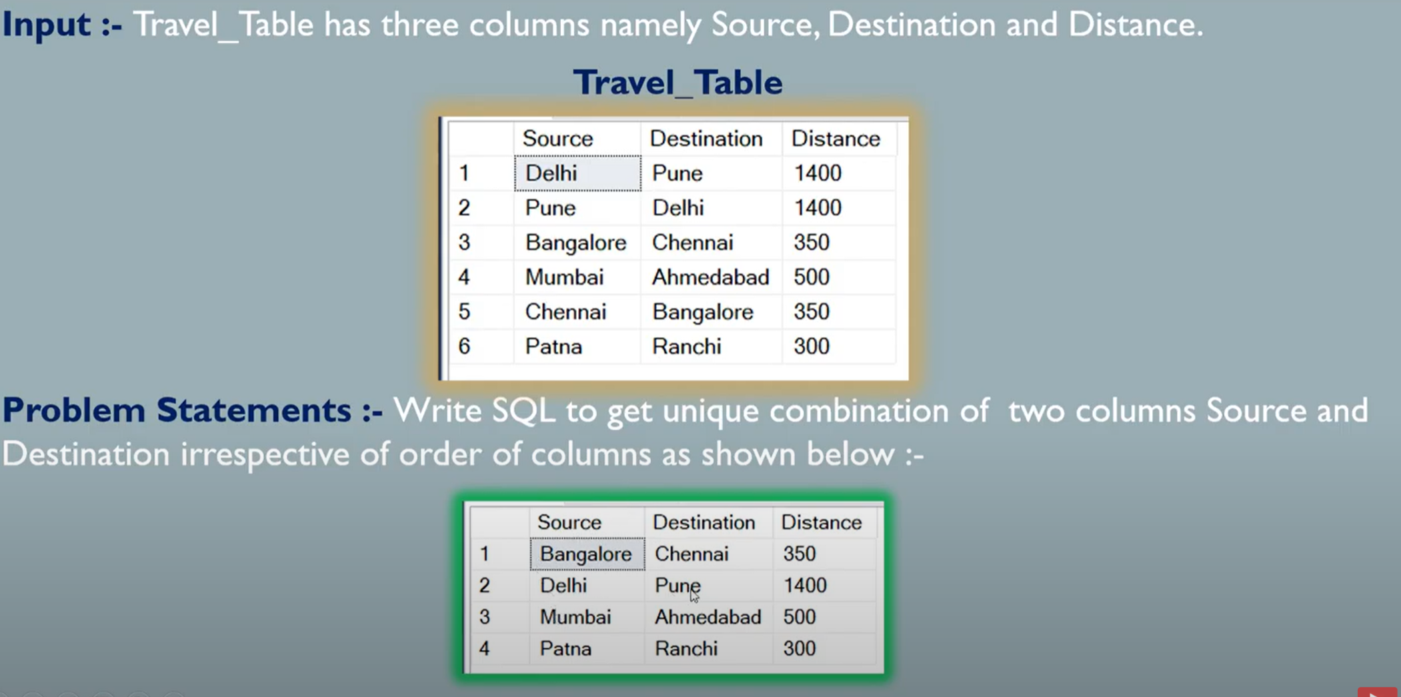

**Q3). Find the Unique combination source and destination?**

SELECT * FROM TRAVEL WHERE SOURCE<DESTINATION

UNION

SELECT * FROM TRAVEL as A

WHERE not exists (SELECT 1 FROM TRAVEL as B

                    WHERE A.SOURCE= B.DESTINATION)

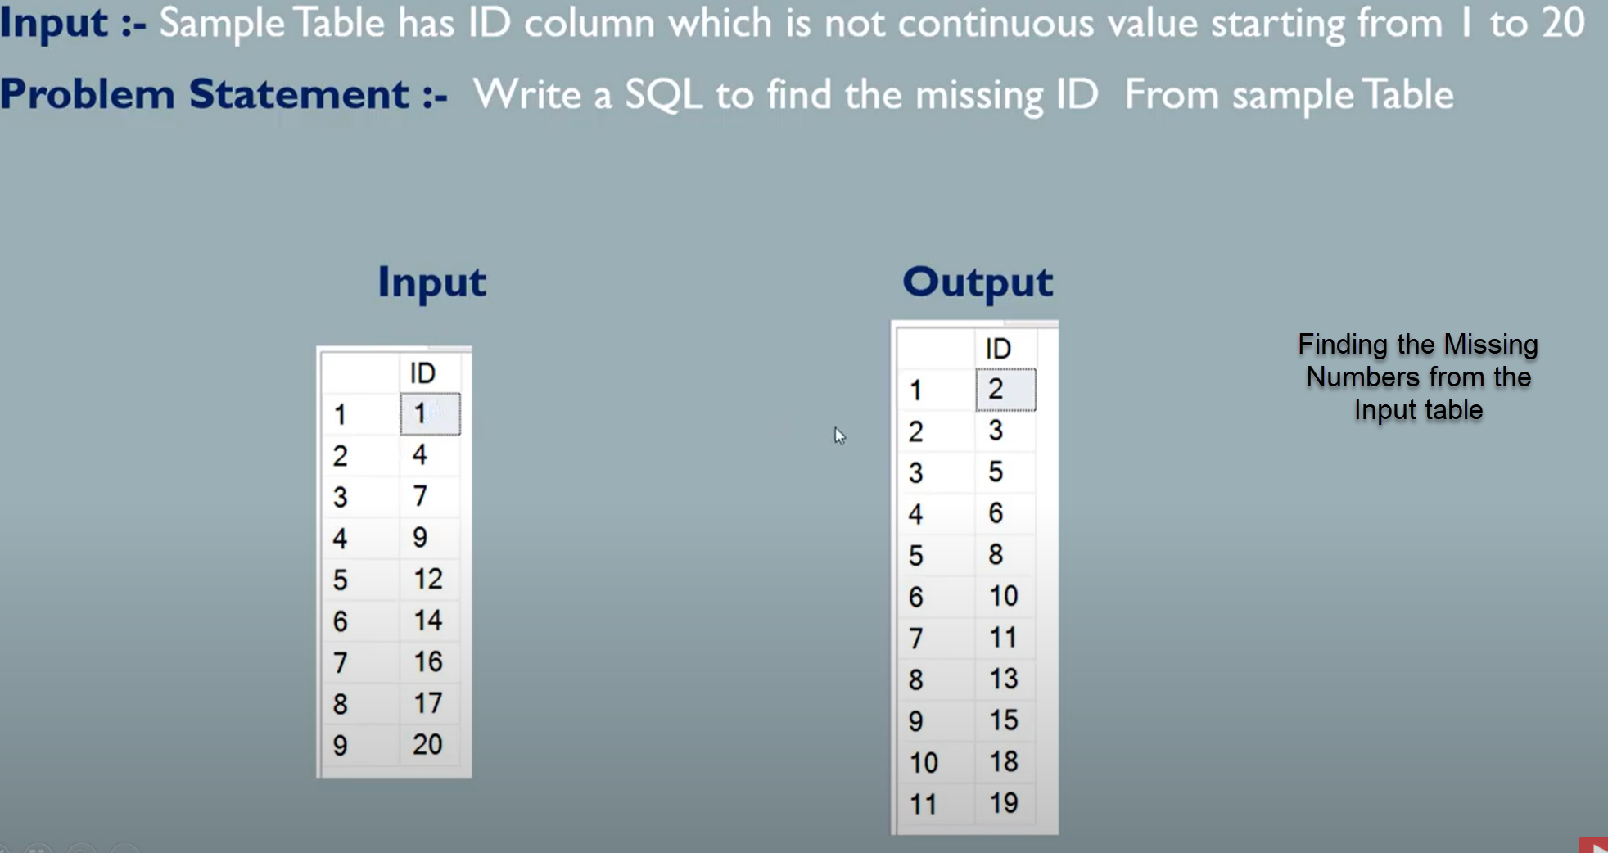

**Q3). Find the missing numbers from the input table?**

WITH CTE_A(

SELECT MAX(ID) MAxid FROM Numbers_Table

)

WITH CTE_B as

(

SELECT Min(ID) as ID FROM Number_Table

UNION ALL

SELECT B.ID+1 FROM CTE_A as A INNER JOIN CTE_B as B

WHERE B.ID<A.MAxid

)

SELECT B.ID FROM CTE_B AS B LEFT OUTER JOIN  Numbers_Table AS C

ON B.ID = C.ID

WHERE C.ID IS NULL

**Q3). Converting the data from Rows to columns?**

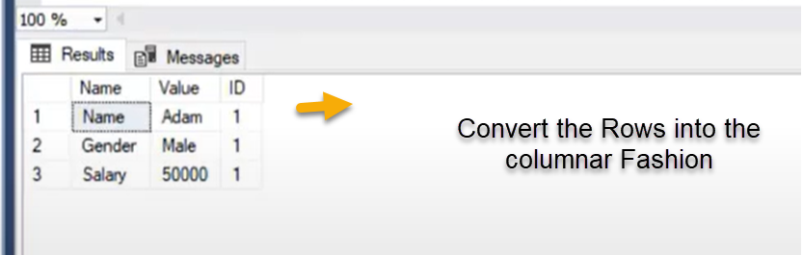

**Result**

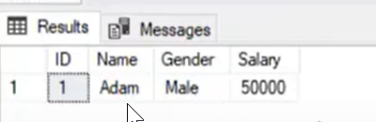

SOLUTION:-

SELECT ID,

max(CASE WHEN NAME = 'NAME' Then Value ELSE '' End) as NAME

max(CASE WHEN NAME = 'GENDER' Then Value ELSE '' End) as GENDER

max(CASE WHEN NAME = 'SALARY' Then Value ELSE '' End) as SALARY

FROM EMPLOYEE

GROUP BY ID

**Q4). Sorting out the salary by month Name i.e display the salary from Jan to Desc**

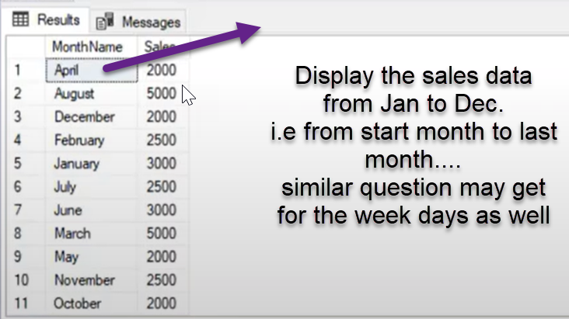

SOLUTION:-

with sales as(SELECT MonthName, CASE WHEN MonthName ='January' then 1

WHEN MonthName ='Feburay' then 2

WHEN MonthName ='March' then 3

WHEN MonthName ='April' then 4

WHEN MonthName ='May' then 5

WHEN MonthName ='June' then 6

WHEN MonthName ='July' then 7

WHEN MonthName ='Augst' then 8

WHEN MonthName ='Sep' then 9

WHEN MonthName ='Oct' then 10

WHEN MonthName ='Nov' then 11

WHEN MonthName ='Dec' then 12

else

0 end monthnumbers, Sales from SALES

)

select MonthName, sales from sales

order by monthnumbers asc

**Q5). Comparing the Previous Quarter sales data with the current quarter sales**

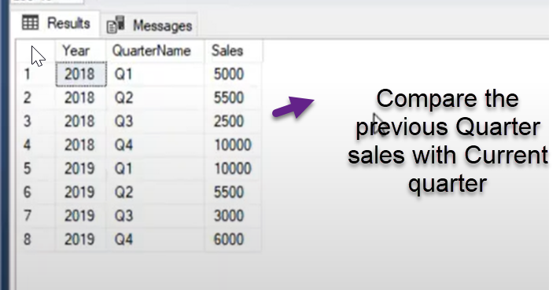

SOLUTION:- SELECT YEAR, QuarterName, Sales as current sales

lag(Sales) over(partition by year order by Quarter ASC) as Previous_Qurtersales

FROM SALES_DATA

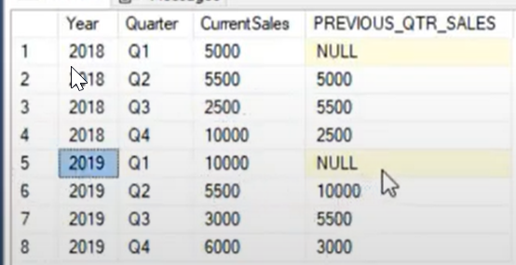

SELECT YEAR, QuarterName, Sales as current sales

lag(Sales, 2) over(partition by year order by Quarter ASC) as Previous_Qurtersales

FROM SALES_DATA

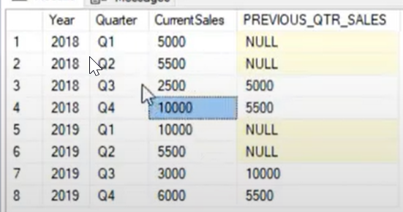

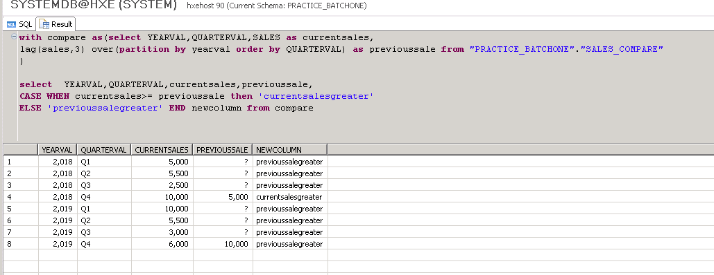

**Q5). Replace special and control characters from the Address column data**

SOLUTION:-

Select firstname,lastname, email, Address, replace(replace(Addresss,' ',''),'@@','') from EMPLOYEE

**Q6) Identifying the Employee name which doesn’t have special characters**

SOLUTION:-

Select email, Employeename From EmployeeTable

Where Employeename like ‘%[^a-z0-9]%’

**Q6) Extracting the only the character from employee name which has both the alphabets and numbers**

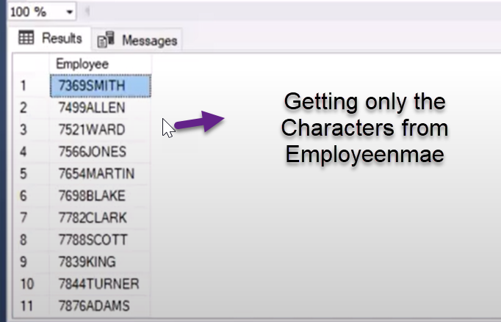

SOLUTION:-

Select EmployeeName, replace_regexpr(‘\d’ in ‘Varapr123prasad’ with ‘’) as cleansed_Employee From EMPLOYEE

**Q6) Running or Cumulative sum**

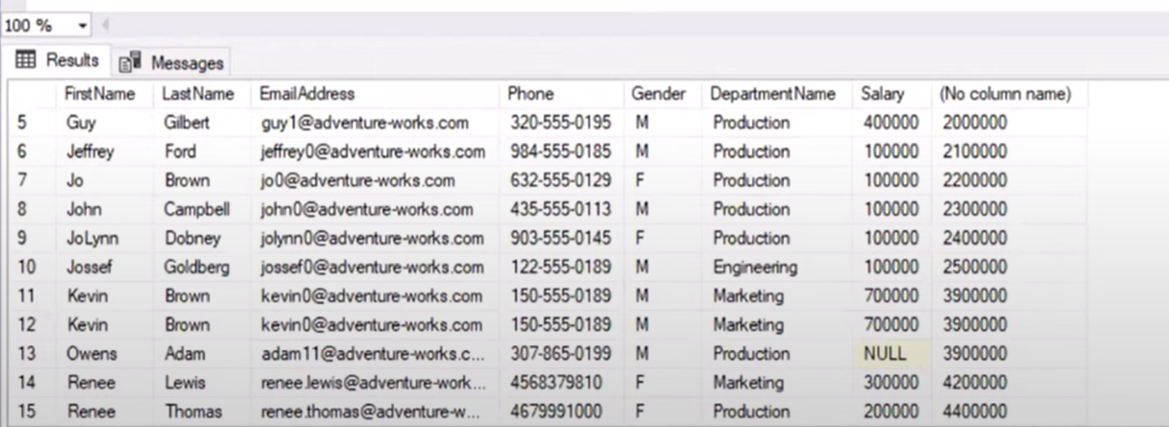

select sum(salary) over(order by employeename) from Employee

**Running Total according to the department**

select sum(salary) over(partition by department order by employeename) from Employee

**Q6) Calaculating the YTD and MTD sales**

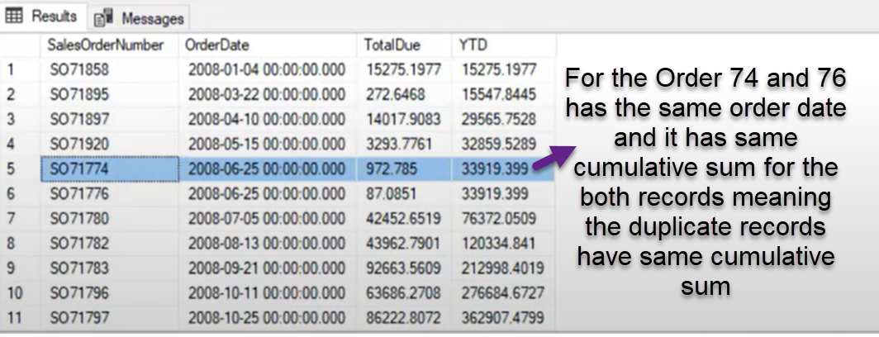

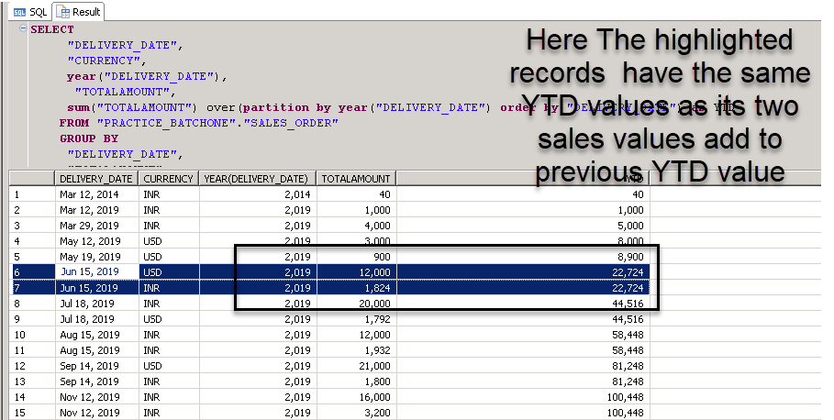

**We can handle above mentioned kind issues by using the window framing functions**

SOLUTION:-

SELECT salesordereNumber, orderdate,TotalDue,

SUM(TotalDue) over(partition by year(orderdate) order by orderdate) as YTD

SUM(TotalDue) over(partition by year(orderdate) order by orderdate rows between unbound preceding AND current row) as YTD_FRAME

FROM SALES_ORDER

This Document contains all my SQL solutions from Leetcode website in order to practice my SQL programming skills. I attempted all questions in 25 days to corroborate my knowledge in SQL.

**EASY QUESTIONS : -**

**Q1. Actors who cooperated with Directors at least three Times’s**

**Table: ActorDirector**

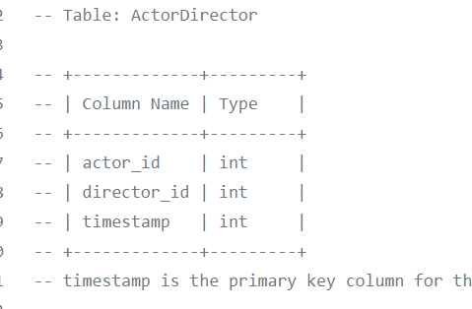

**timestamp is the primary key column for this table.**

**Write a SQL query for a report that provides the pairs (actor_id, director_id) where the actor have cooperated with the director at least 3 times.**

**Example:**

**Actor Director table:**

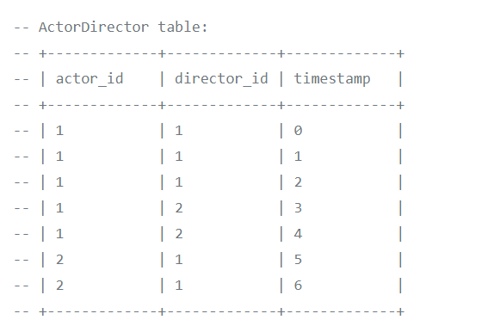

|  |
| --- |
|  |
| **Result** |
|  | +-------------+-------------+ |
|  | | actor_id | director_id | |
|  | +-------------+-------------+ |
|  | | 1 | 1 | |
|  | -- +-------------+-------------+ |
|  | The only pair is (1, 1) where they cooperated exactly 3 times. |
|  |  |

**-- Solution**

**Select actor_id, director_id**

**from actordirector**

**group by actor_id, director_id**

**having count(*)>=3**

## **Q2) Ads performance’s sql**

|  |  |
| --- | --- |
| **Column Name** | **Type** |
| ad_id | int |
| user_id | int |
| Action | enum |

**(ad_id, user_id) is the primary key for this table.**

**Each row of this table contains the ID of an Ad, the ID of a user and the action taken by this user regarding this Ad.**

**The action column is an ENUM type of ('Clicked', 'Viewed', 'Ignored').**

**A company is running Ads and wants to calculate the performance of each Ad.**

**Performance of the Ad is measured using Click-Through Rate (CTR) where:**

**Write an SQL query to find the ctr of each Ad.**

**Round ctr to 2 decimal points. Order the result table by ctr in descending order and by ad_id in ascending order in case of a tie.**

**The query result format is in the following example:**

**Ads table**

|  |  |  |
| --- | --- | --- |
| **ad_id** | **user_id** | **action** |
|  |  |  |
| 1 | 1 | Clicked |
| 2 | 2 | Clicked |
| 3 | 3 | Viewed |
| 5 | 5 | Ignored |
| 1 | 7 | Ignored |
| 2 | 7 | Viewed |
| 3 | 5 | Clicked |
| 1 | 4 | Viewed |
| 2 | 11 | Viewed |
| 1 | 2 | Clicked |

**-- Result table:**

|  |  |
| --- | --- |
| **ad_id** | **ctr** |
| **1** | **66.67** |
| **3** | **50** |
| **2** | **33.33** |
| **5** | **0** |

-- Solution

with t1 as (select ad_id, sum(case when action in ('Clicked') then 1 else 0 end) as clicked

from ads

group by ad_id),

t2 as (

Select ad_id as ad, sum(case when action in ('Clicked','Viewed') then 1 else 0 end) as total

from ads

group by ad_id)

Select a.ad_id, coalesce(round((clicked +0.0)/nullif((total +0.0),0)*100,2),0) as ctr

From (select *

from t1 join t2

on t1.ad_id = t2.ad) a

order by ctr desc, ad_id

**Q3) Article views.sql**

**Table views**

|  |  |
| --- | --- |
| **Column Name** | **Type** |
| article_id | Int |
| author_id | Int |
| viewer_id | Int |
| view_date | Date |

**There is no primary key for this table, it may have duplicate rows.**

**Each row of this table indicates that some viewer viewed an article (written by some author) on some date.**

**Note that equal author_id and viewer_id indicate the same person.**

**---Write an SQL query to find all the authors that viewed at least one of their own articles, sorted in ascending order by their id.**

**The query result format is in the following example:**

**Views table:**

|  |  |  |  |
| --- | --- | --- | --- |
| article_id | author_id | viewer_id | view_date |
| 1 | 3 | 5 | 8/1/2019 |
| 1 | 3 | 6 | 8/2/2019 |
| 2 | 7 | 7 | 8/1/2019 |
| 2 | 7 | 6 | 8/2/2019 |
| 4 | 7 | 1 | 7/22/2019 |
| 3 | 4 | 4 | 7/21/2019 |
| 3 | 4 | 4 | 7/21/2019 |

|  |
| --- |
| Id |
| 4 |
| 7 |

-- Solution

select distinct author_id as id

from views

where author_id = viewer_id

order by author_id\

**Q4) Average selling price.sql**

**Table: Prices**

|  |  |
| --- | --- |
| **Column Name** | **Type** |
| product_id | Int |
| start_date | Date |
| end_date | Date |
| Price | Int |

**(product_id, start_date, end_date) is the primary key for this table.**

**Each row of this table indicates the price of the product_id in the period from start_date to end_date.**

**For each product_id there will be no two overlapping periods. That means there will be no two intersecting periods for the same product_id.**

**Table: UnitsSold**

|  |  |
| --- | --- |
| **Column Name** | **Type** |
| product_id | Int |
| purchase_date | Date |
| Units | Int |

**There is no primary key for this table, it may contain duplicates.**

**Each row of this table indicates the date, units and product_id of each product sold.**

**Write an SQL query to find the average selling price for each product.**

**The average price should be rounded to 2 decimal places.**

**The query result format is in the following example:**

**Prices table:**

|  |  |  |  |
| --- | --- | --- | --- |
| **product_id** | **start_date** | **end_date** | **price** |
| 1 | 2/17/2019 | 2/28/2019 | 5 |
| 1 | 3/1/2019 | 3/22/2019 | 20 |
| 2 | 2/1/2019 | 2/20/2019 | 15 |
| 2 | 2/21/2019 | 3/31/2019 | 30 |

**UnitsSold table:**

|  |  |  |
| --- | --- | --- |
| **product_id** | **purchase_date** | **units** |
| 1 | 2/25/2019 | 100 |
| 1 | 3/1/2019 | 15 |
| 2 | 2/10/2019 | 200 |
| 2 | 3/22/2019 | 30 |

**Result table:**

|  |  |
| --- | --- |
| **product_id** | **Average_price** |
| 1 | 6.96 |
| 2 | 16.96 |

**Average selling price = Total Price of Product / Number of products sold.**

**Average selling price for product 1 = ((100 * 5) + (15 * 20)) / 115 = 6.96**

**Average selling price for product 2 = ((200 * 15) + (30 * 30)) / 230 = 16.96**

-- Solution

Select d.product_id, round((sum(price*units)+0.00)/(sum(units)+0.00),2) as average_price

from(

Select *

from prices p

natural join

unitssold u

where u.purchase_date between p.start_date and p.end_date) d

group by d.product_id

## **Q5) Big Countries.sql**

**There is a table World**

|  |  |  |  |  |
| --- | --- | --- | --- | --- |
| **name** | **continent** | **area** | **population** | **Gdp** |
| Afghanistan | Asia | 652230 | 25500100 | 20343000 |
| Albania | Europe | 28748 | 2831741 | 12960000 |
| Algeria | Africa | 2381741 | 37100000 | 188681000 |
| Andorra | Europe | 468 | 78115 | 3712000 |
| Angola | Africa | 1246700 | 20609294 | 100990000 |

**A country is big if it has an area of bigger than 3 million square km or a population of more than 25 million.**

**Write a SQL solution to output big countries' name, population and area.**

**For example, according to the above table, we should output:**

|  |  |  |
| --- | --- | --- |
| **name** | **population** | **area** |
| Afghanistan | 25500100 | 652230 |
| Algeria | 37100000 | 2381741 |

Solution

Select name, population, area

from world

where population > 25000000 OR area>3000000

**Question7**

**There is a table courses with columns: student and class**

**Please list out all classes which have more than or equal to 5 students.**

**For example, the table:**

|  |  |
| --- | --- |
| **student** | **class** |
| A | Math |
| B | English |
| C | Math |
| D | Biology |
| E | Math |
| F | Computer |
| G | Math |
| H | Math |
| I | Math |

-- Solution

select class

from courses

group by class

having count(distinct student)>=5

## **Q8).Combine two tables.sql**

**Table: Person**

|  |  |
| --- | --- |
| **Column Name** | **Type** |
| PersonId | int |
| FirstName | varchar |
| LastName | varchar |

**PersonId is the primary key column for this table.**

**Table: Address**

|  |  |
| --- | --- |
| **Column Name** | **Type** |
| AddressId | int |
| PersonId | int |
| City | varchar |
| State | varchar |

**AddressId is the primary key column for this table.**

**Write a SQL query for a report that provides the following information for each person in the Person table, regardless if there is an address for each of those people:**

**FirstName, LastName, City, State**

-- Solution

select FirstName, LastName, City, State

from Person P left join Address A

on P.PersonId = A.PersonId

## **Q8). Create Session bar chart.sql**

**Table: Sessions**

|  |  |
| --- | --- |
| Column Name | Type |
| session_id | int |
| duration | int |

session_id is the primary key for this table.

duration is the time in seconds that a user has visited the application.

You want to know how long a user visits your application. You decided to create bins of "[0-5>", "[5-10>", "[10-15>" and "15 minutes or more" and count the number of sessions on it.

**Write an SQL query to report the (bin, total) in any order.**

The query result format is in the following example.

|  |  |
| --- | --- |
| **session_id** | **duration** |
| 1 | 30 |
| 2 | 199 |
| 3 | 299 |
| 4 | 580 |
| 5 | 1000 |

**Result table:**

|  |  |
| --- | --- |
| **bin** | **total** |
| [0-5> | 3 |
| [5-10> | 1 |
| [10-15> | 0 |
| 15 or more | 1 |

**For session_id 1, 2 and 3 have a duration greater or equal than 0 minutes and less than 5 minutes.**

**For session_id 4 has a duration greater or equal than 5 minutes and less than 10 minutes.**

**There are no session with a duration greater or equial than 10 minutes and less than 15 minutes.**

**For session_id 5 has a duration greater or equal than 15 minutes.**

-- Solution 2

(Select '[0-5>' as bin,

 sum(case when duration/60 < 5 then 1 else 0 end) as total from Sessions)

 union

(Select '[5-10>' as bin,

 sum(case when ((duration/60 >= 5) and (duration/60 < 10)) then 1 else 0 end) as total from Sessions)

 union

(Select '[10-15>' as bin,

 sum(case when ((duration/60 >= 10) and (duration/60 < 15)) then 1 else 0 end) as total from Sessions)

 union

(Select '15 or more' as bin,

 sum(case when duration/60 >= 15 then 1 else 0 end) as total from Sessions)